


Scope and Storyboard for Cost Negotiations

AMR Manchester

By SVR

Table of Contents

1 Document Revision History 2
1.1. Document Location 2
1.2. Revision History 2
1.3. Approvals 2
1.4. Distribution 2
2 Summary of Scope 3
3 Screen design 4
4 Workflow 14
5 Navigation 15
6 SQL Tables 16
7 Stored Procedures 17
8 Tasks & Reminders 18
9 Document Templates 19

Document Revision History

Document Location
Full File Path
2011-10-18 FL041 Scope and Storyboard for Costs Negotiation V0.4.doc

Revision History
Version Number | Revision Date | Summary of Changes | Changes marked | Author
0.1 | 18/10/2011 | First issue | N/A | SVR
0.2 | 21/10/2011 | Senior Business Analyst Review | No | SVR
0.3 | 25/10/2011 | LMW Comments | Tracked | LMW
0.4 | 25/10/2011 | SVR Responses | Tracked | SVR

Approvals
Name | Signature | Title | Date of Issue | Version

Distribution
Name | Title | Date of Issue | Version

Summary of Scope

The purpose of this scope is to outline the provisions that the FloCase system will need to make to allow users to handle the process of cost negotiations.

It is envisioned that whilst the process itself may be of a complex nature the system should provide a simplified generic solution that merely tracks dates and has a certain amount of supervision inbuilt to assist the Team Leaders in ensuring key tasks involved in these process are dealt with in a timely manner.

  - Costs Negotiations

Negotiations on the issue of Costs are similar in many respects to the process of Offers to settle. As a result, the development requirements of this scope are intended to be enhancements of and additions to the functionality developed for Offers in release 5.10.

Screen design

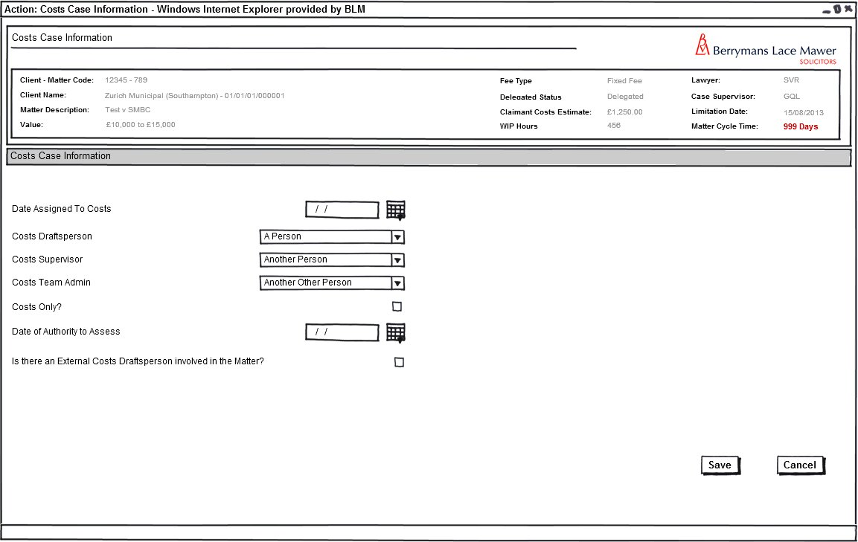
  - Assign Case to Costs

Fig 1: Form Costs Case Information

    - Form Availability

This form should only be available from selection of the task “Assign Case to Costs” from the Case Actions Screen

    - Form Behaviour on Load

If run for the first time, i.e. there is a null value in dbo.Case_CostsAssgn, the form should load with no information pre-populated.

If the form is run where there is a value (1) in dbo.Case_CostsAssgn, the form should load with previously saved data pre-populated using new stored procedure LTMM_Costs_Fetch

    - Form Items

Date Assigned to Costs? – Label as stated with associated mandatory Date Picker.

Save value to CaseKeyDates_KeyDatesCode with @pKeyDatesCode = ‘CostsAssignDate’

Save Bit value to dbo.Case_CostsAssgn [Bit] Null

Costs Draftsperson – Label as stated with associated mandatory Combo Box populated by dbo.AppUser_Fetch

Save Value to table dbo.AppUser with new @pAppUserRoleCode ‘CFE’ (new AppUserRoleType required for Costs Draftsperson with code stated and access level same as senior Fee Earner)

Costs Supervisor – Label as stated with associated mandatory Combo Box populated by dbo.AppUser_Fetch

Save Value to table dbo.AppUser with new @pAppUserRoleCode ‘CTL’ (new AppUserRoleType required for Costs Supervisor with code stated and access level same as senior Team Leader)

Team Administrator – Label as stated with associated mandatory Combo box populated by dbo.AppUser_Fetch

Save Value to table dbo.AppUser with new @pAppUserRoleCode ‘CTA’ (new AppUserRoleType required for Costs Team Administrator with code stated and access level same as senior Team Administrator)

Costs Only? – Label as stated with associated check-box.

Save value to field in table dbo.Case_CostsOnly (Bit), Null

Date of Authority to Assess – Label as stated with associated date picker.

Save Value to dbo.CaseKeyDates with @pKeyDatesCode = ‘CostsAuthAss’

Is there an External Costs Draftsperson Involved in the Matter? – Label as stated with associated Check-Box

    - Form Behaviour on Save

Where a valid date has been entered in the Date Assign to Costs field, write Bit value (1) to dbo.Case_CostsAssgn

The system should record a history line to table dbo.AppTask: “Case assigned to Costs on <CostsAssignDate>”

Save values to new fields using new stored procedure dbo.LTMM_Costs_Save

Schedule “Update Costs Milestone Dates” immediately (i.e: scheduled for the date at the point of submission) for Costs Team Administrator entered on the form shown in figure 1 above (see FLO42 Scope and Storyboard for Costs Assessment for more details) using stored Procedure dbo.AppTask_CreatePending

Schedule “N252 (Notice of Commencement) receipt required by <date>” for 3 Months from the Date of Authority to Assess for the Costs Draftsperson on the Matter entered on the form shown in figure 1 above using stored Procedure dbo.AppTask_CreatePending

Schedule “N258 (Request for Hearing) receipt required by <date>” for 6 Months from the Date of Authority to Assess for the Costs Draftsperson on the Matter entered on the form shown in figure 1 above using stored Procedure dbo.AppTask_CreatePending

Schedule “Carry out Part 8 Assessment” for 3 Months from the Date Assigned to Costs for the Costs Draftsperson on the Matter entered on the form shown in figure 1 above using stored Procedure dbo.AppTask_CreatePending

Schedule “Draft Costs Negotiation Advice To Client” immediately for the Costs Draftsperson in the Matter

IF “Is there an External Costs Draftsperson Involved in the Matter?” Check box is selected, Message Prompt stating “Add External Costs Draftsperson” .

Load Costs MI screen – See Scope Reference FLO***** re: Costs MI

    - Form Behaviour on Cancel

Return to Case Actions Screen
  - Update Costs Milestone Dates (Task without Form for Team Administrator)

    - Task Behaviour on Select

Load Costs Directions Tab immediately

Set Update Costs Milestone Dates task as complete

  - Draft Costs Negotiation Advice to Client (Task without Form for Costs Draftsperson)

    - Task Behaviour on Select

Produce Draft Costs Negotiation Advice to Client Letter for Costs Draftsperson in the Matter to edit, with approval as per Supervision of Client Communication (FLO32).

Note: the costs user structure does not yet fit into the existing document supervision functionality. The Costs user structure will need to be added to the Supervision of client Communication (FLO32) as part of the 5.11 Costs Release

  - Make Offer

    - Offer History Summary Screen
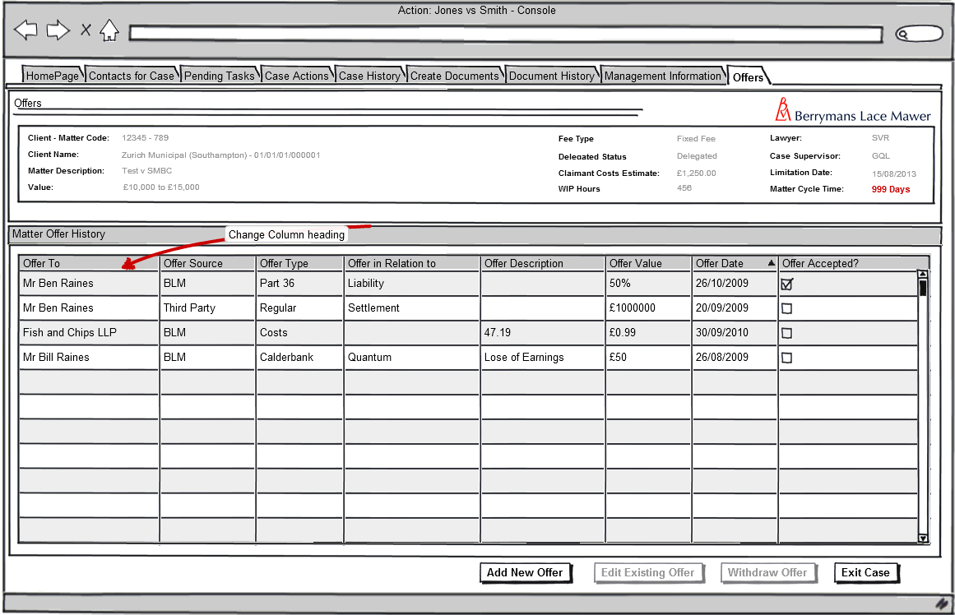
Figure 2 – Offer History Summary Tab

    - Form Availability

This tab is pre-existing and available from the Tab bar at the top of the Matter Landing (Home) Page. It allows the user to view the details of all previous offers against a matter. It also acts as starting point for adding the details of new offers and amendment of any existing offers held against that matter.

    - Form Behaviour On Load

The form should load with the offers grid populated via existing stored procedure LTMM_Offers_Fetch, this will display the following details for all offers currently attached to the matter:

- Offer To - @pOffers_CaseContactID
- Offer Source – @pOffers_OfferSource
- Offer Type – @pOffers_OfferType
- Offer in Relation to – @pOffers_OfferRelation
- Offer Description – @pOffers_OfferDesc
- Offer Value – @pOffers_OfferMoneyValue or @pOffers_OfferPercentageValue
- Offer Date – @pOffers_OfferDate
- Offer Accepted – @pOffers_OfferAccepted

In addition to this the stored procedure should also fetch the following CRU related information for each claimant displayed in the grid where applicable (NB this will not apply to Offers of type ‘Costs’):

- Offer Code – @pOffers_OfferCode

Amendment to the stored procedure is required to allow for the inclusion of Offers of type ‘Costs’ and to change the displayed column heading from Claimant Name’ to ‘Offer To’

    - Form Items

No additional form items required

    - Form Behaviour on Submit

No deviation from existing submission functionality

    - Form Behaviour on Cancel

n/a

  - Make New Offer

The functionality for making and editing Offers as part of a settlement on a Matter was delivered to FloCase in release 5.10. Much of this functionality will remain as delivered in that release. This scope will not therefore describe the functionality already delivered, but will describe deviations from that functionality in order to make offers on Costs.

NB The content of the form will not change from the current content (i.e. controls and pick-lists will be exactly as currently implemented). The only change will be to allow the selection of the Offer type prior to the selection of a recipient and the position of the Offer Type Control to support this. Selection of an Offer Type of ‘Costs’ will result only in a reduced set of controls. All controls will maintain their existing table and field relationship.

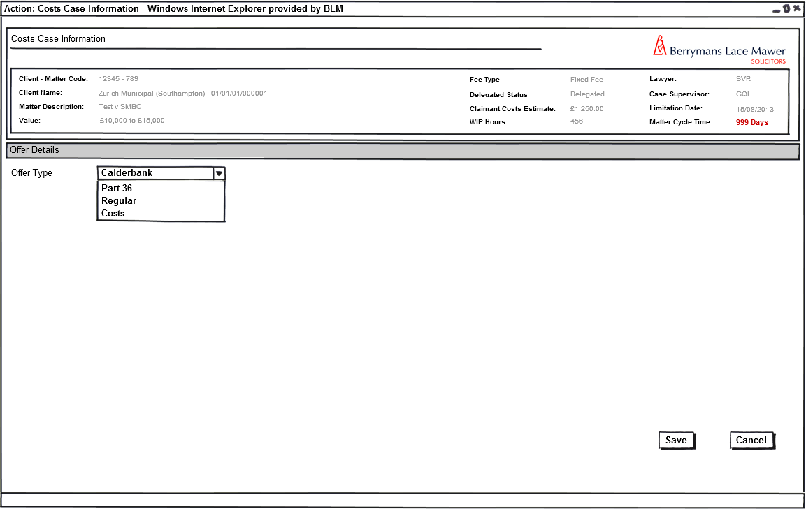
Fig 3: Costs Offer (Form 1):

    - Form Availability

This form will be launched from the Add New Offer button on the Offers tab shown in section 3.7 above. This form should not be available ad-hoc from the case actions screen.

    - Form Behaviour On Load

The form should load with no data pre-populated

    - Form Items

Offer Type – Label as stated with associated mandatory combo-box having the following options (Populated using LTMM_LookupCodes_Fetch with @LookupTypeCode = 'OFRTYPE', @BlankRow = 1):
  - Calderbank
  - Part 36
  - Regular
  - Costs **New Addition**

Selection of the Offer Types: ‘Calderbank’, ‘Part 36’, ‘Regular’ will load the following form. Note new position of Offer Type placeholder: All other controls and placeholders will remain as currently implemented.

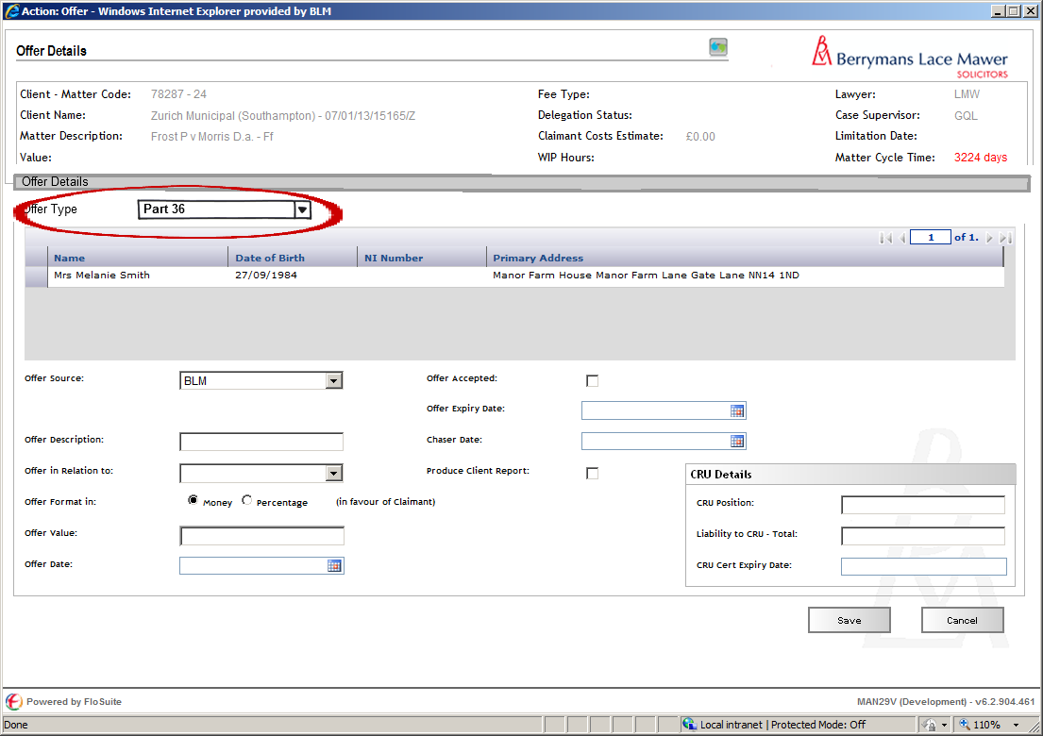
Fig 4: Make New Offer - Form when Offer Type <> ‘Costs’ - Note Changed position of Offer Type Field

Selection of the Offer Type: ‘Costs’ will load the following form:
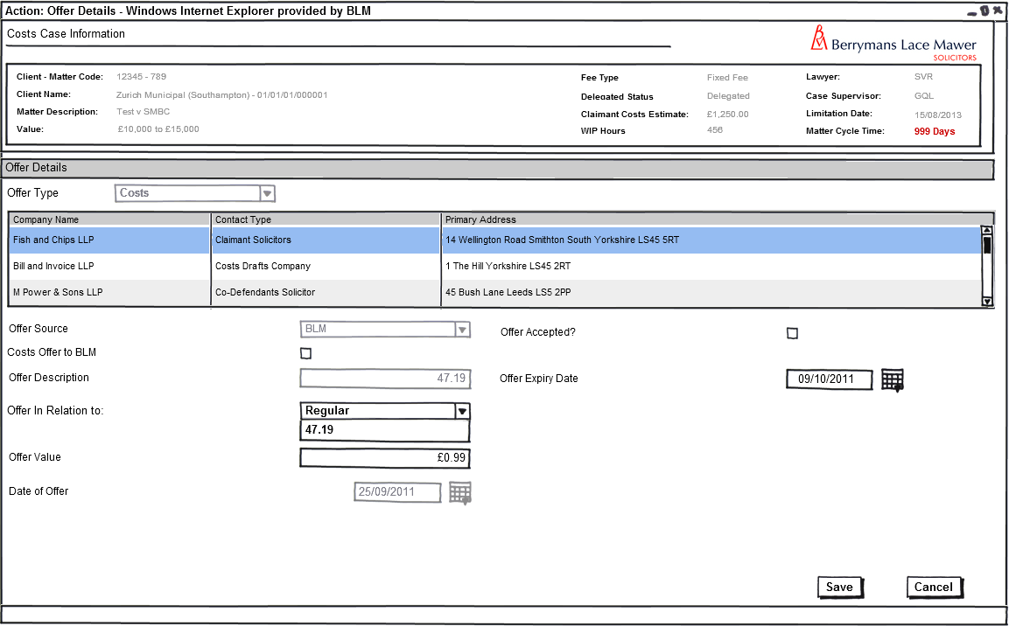
Fig 5: Make New Offer – Form when Offer Type = Costs

The form should load with the select grid populated via a new stored procedure LTMM_Costs_Fetch, this will display the following details for all Claimants Solicitors, Co-Defendant’s Solicitors and External Costs Draftspersons currently attached to the matter:

- Company Name
- Contact Type
- Primary Address

If the form is derived from the user selecting to Edit an Existing offer on the previous Offer tab then this form should load with all the existing data of the selected offer pre-populated using LTMM_Offers-Fetch passing the offer code of the selected offer (@pOffers_OfferCode).

If the form is derived from the user selecting to Add New offer on the previous Offer tab and there is only one relevant contact on the matter then the form should default to that contact.

    - Form Items

The form should load with the following existing controls, exclusive of those items not required for Costs Offers

Costs Offer to BLM – Label as stated with associated check box.

Offer Source – Label as stated with associated Mandatory Combo box having the following options (Populated using LTMM_LookupCodes_Fetch with @LookupTypeCode = 'OFRSRCE', @BlankRow = 1):
- BLM
- Third Party

Offer Description – Label as stated with associated mandatory text box

Offer In Relation To – Label as stated with associated Mandatory Combo box having the following options (Populated using LTMM_LookupCodes_Fetch with @LookupTypeCode = 'OFRRLTN', @BlankRow = 1):

- 47.19
- Regular

Offer Value – Label as stated with associated mandatory Textbox formatted to accept currency values.

Offer Date – Label as stated with associated mandatory Date Picker.

Offer Accepted – Label as stated with associated checkbox denoting if an offer has been accepted or not (Checked = Accepted).

Offer Expiry Date – Label as stated with associated Date Picker.

    - Form Behaviour on Save

The following form save behaviour is in addition to the existing form submission behaviour and is specific to offers of type Costs

Write history line Costs Offer Added for <<Contact>>

If Offer Accepted = Checked, Write history line Costs Offer Accepted by <<Contact>> for <<Offer Value>>

Should return to the Costs MI Tab.

If Offer Accepted = Not checked, Schedule Check Offer Acceptance for <OfferExpiry> date for Costs Draftsperson in the Matter.

The costs offer should use the same sp matters as the existing offers functionality. I.e. Use Stored Procedure LTMM_Offers_Save to save the following details entered on the form:

- Selected Contact – @pOffers_CaseContactID
- Offer Code (if a previous Offer is being edited) – @pOffers_OfferCode
- Offer Source – @pOffers_OfferSourceCode
- Offer Type – @pOffers_OfferTypeCode
- Offer Description – @pOffers_OfferRelationCode
- Offer Format In – @pOffers_OfferMoneyValue
- Offer Value – @pOffers_OfferPercentageValue
- Offer Date – @pOffers_OfferDate
- Offer Expiry - @pOffers_ExpiryDate
- Offer Accepted – @pOffers_OfferAccepted

An additional save item is required for the Costs Offer to BLM Check Box

- Costs Offer to BLM – @pOffers_CostsOfferToBLM

Return to the Pending Tasks page

  - Accept, Withdraw or Edit Offer

Costs offers will be subject to the same rules and functionality as already implemented in the existing Offers scope.

    - Form Behaviour on Cancel

Return to the offers tab.

- Reminder Tasks

  - Check Offer Acceptance

    - Task Behaviour on Complete Task

Load Offers History Tab to Accept, Withdraw or Edit offer.

Set Check Offer Acceptance task as Complete

  - N252 (Notice of Commencement) required by <date>

    - Task Behaviour on Complete Task

Load Costs Dates Tab to enter dates

Set N252 (Notice of Commencement) required by <date> task as Complete

  - N258 (Request for Hearing) required by <date>

    - Task Behaviour on Complete Task

Load Costs Dates Tab to enter dates

Set N258 (Request for Hearing) required by <date> task as Complete

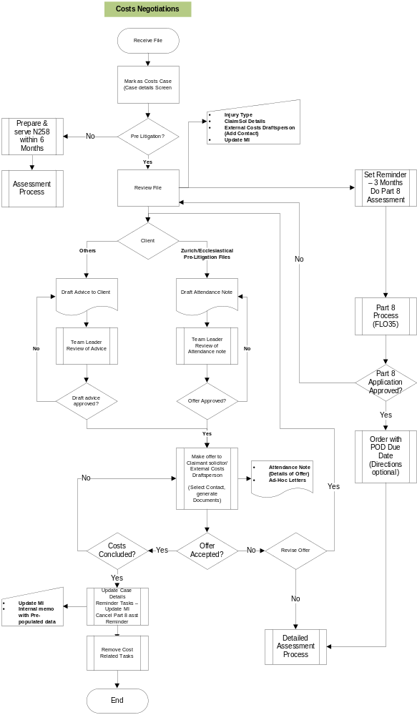
Workflow

  - Costs Negotiation

Fig 6 – Costs Negotiations Process

Navigation

  - Where will the Flow be launched from

The flow for Costs Negotiations will be launched Ad-hoc from the Case Actions screen.

  - Where should the Flow return to

- See Each Form for flow returns

SQL Tables

  - Tables

    - New Data Table

New Fields Required in the Case table:

Dbo.Case_CostsAssgn [Bit] Null
Dbo.Case_CostsOnly [Bit] Null

New Field required in the Offers Table:

Dbo.Offers_CostsOfferToBLM

  - Lookup

New Look-up values required of contact types:

Co-Defendant Solicitors – A ticket has already been raised relating to this particular contact type
External Costs Draftsperson/Company – New Ticket to be raised for this Editable Contact Type

New Lookup Values of Offer In Relation To (OFRRLTN) :

- 47.19
- Regular
  - Fields & Forms

Label | Input Type | Table | Field Name | Field Value Type | Mandatory? | Rule | Form | Description

Stored Procedures

  - Fetch

New Stored Procedure:

- LTMM_Costs_Fetch

Amendment to Stored Procedure:

- LTMM_Offers_Fetch

  - Save

New Stored Procedure:

- LTMM_Costs_Save

Amendment to Stored Procedure:

- LTMM_Offers_Save

Tasks & Reminders

Task | Who On | Trigger | Behaviour on Select | Scheduling | Conditions/Parameters
Assign Case to Costs | Ad-Hoc | Ad-Hoc | Load Costs Case Information Form | Ad-Hoc | None
Update Costs Milestone Dates | Team Admin | Save Form Costs Case Information | Load Costs Direction Tab | Immediate | None
N252 (Notice of Commencement)required by <date> | Costs Draftsperson (Fee earner) | Save Form Costs Case Information | Load Costs Direction Tab | 3 Months from Date of Authority to Assess | Cancel upon receipt of N252 (ad-hoc tasks) being run
N258 (Request for Hearing) required by <date> | Costs Draftsperson (Fee earner) | Save Form Costs Case Information | Load Costs Direction Tab | 3 Months from Date of Authority to Assess | Retain unless Case Closed
Carry Out Part 8 Assessment | Costs Draftsperson (Fee earner) | Date 3 months from Date assigned to Costs | Load Case Actions Screen | 3 Months from Date assigned to Costs | Cancel if Part 8 Task is run
Draft Costs Negotiation Advice to Client | Costs Draftsperson (Fee earner) | Save Form Costs Case Information | Produce Non-Delegated Advice to Client Form/Letter as supplied by Costs | Immediately | Where Client is not of Type Zurich
Check Offer Acceptance | Costs Draftsperson | Save Form on Offer Screen where “Offer Accepted” checkbox not selected | Load Offers History Tab | Offer Expiry Date | None

Document Templates

Please list below details of any document required as part of this scope.

Status:  New / Existing / Replacement  (please state) | Received Document Name (from business) | Document File Name  (ie Document.dot) | Document Description  (as viewed on FloCase) | Template Description Code  (Code for auto description) | Template Group:  BLM/ Documents/ Court Doc/ Letters/ Other  (Please State)
New | Not Yet Received | TBA | Costs Negotiation Advice to Client Letter | TBA | Letters

/tmp/lo/0000.doc

